CL-N52-0.1.7 Test
일시: 2026. 5. 26
작성자: SW개발실 이승희 선임매니저

시리얼 통신 데스트 (UART)
- 사용 툴 (find data v8; AS 로그분석 시 사용하는 데이터 추출 툴)
- 로그 기록
I: w25q256@0: SFDP v 1.5 AP ff with 1 PH
I: PH0: ff00 rev 1.5: 16 DW @ 80
I: w25q256@0: 32 MiBy flash
*** Booting MCUboot v2.1.0-dev-12e5ee106034 ***
*** Using nRF Connect SDK v2.9.0-7787b2649840 ***
*** Using Zephyr OS v3.7.99-1f8f3dc29142 ***
I: Starting bootloader
I: Image index: 0, Swap type: none
I: Bootloader chainload address offset: 0xe000
I: Jumping to the first image slot
*** Booting nRF Connect SDK v2.9.0-7787b2649840 ***
*** Using Zephyr OS v3.7.99-1f8f3dc29142 ***
Start! CLK=64MHz, IMU=4G,500DPS, TIMER=50Hz, VER=CL-N52-0.1.7
<RST - C-Light>
gpio : ok
uart : ok
timer : ok
tick : ok
adc : ok
spi : ok
exflash : ok
twi : ok
imu : ok
rtc : ok
ble : ok
ID : SW01GyNw (E7:5B:23:C8:F8:1A)
TIME : 2026-05-26 11:18:22
USAGE : 9370d18h6m58s, 82 times used.
BATTERY : 2280, 8 times charged.
0221 time[0] : 2026-05-26 11:11:02 -67 B:127
0222 time[1] : 2026-05-26 11:10:59 67 B:128
0223 time[0] : 2026-05-26 11:11:15 -66 B:128
0224 time[1] : 2026-05-26 11:11:16 66 B:129
0225 time[2] : 1970-01-01 14:15:49 66 T:5
0226 time[3] : 2026-05-26 11:11:46 -1 B:0
0227 time[0] : 2026-05-26 11:11:47 -65 B:129
0228 time[1] : 2026-05-26 11:11:49 65 B:130
0229 time[0] : 2026-05-26 11:13:01 -68 B:130
0230 time[1] : 2026-05-26 11:13:03 68 B:131
0231 time[2] : 2106-02-02 21:17:30 68 T:5
0232 time[0] : 2026-05-26 11:13:34 -67 B:131
0233 time[1] : 2026-05-26 11:13:46 67 B:132
0234 time[0] : 2026-05-26 11:17:24 -66 B:134
0235 time[1] : 2026-05-26 11:17:21 66 B:135
0236 time[0] : 2026-05-26 11:18:23 -69 B:135
0237 time[1] : 2026-05-26 11:18:22 69 B:136
DATA_STORE : allocated (20007638, 2400 bytes)
MODE : 1
PAUSE : disabled
System Ready!
sdata_block : 136
trigger, enabled.

- Dnt 로그 배터리 기록 이슈
전원 오프 시점에 배터리 기록이 음수로 표현됨
- 검출 시점 기록 시간 이슈
검출 시점 T: 5, 3 등 기록될 때 시간 데이터가 깨짐
0224 time[1] : 2026-05-26 11:11:16 66 B:129
0225 time[2] : 1970-01-01 14:15:49 66 T:5
0226 time[3] : 2026-05-26 11:11:46 -1 B:0
0227 time[0] : 2026-05-26 11:11:47 -65 B:129

- 데이터 추출
  - sData 데이터 추출
단일(다중) 블록 데이터 추출 정상 작동 확인
Csv. 파일에서 첫 줄에 더미 데이터? 존재 이슈
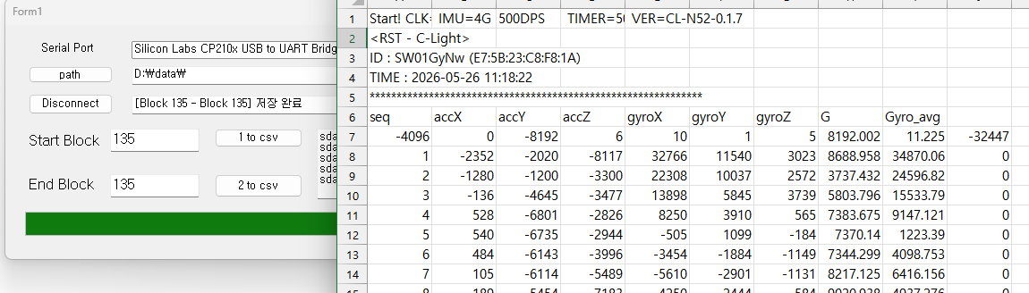

  - Trigger 데이터 추출
트리거 데이터 추출 시 빈 파일로 추출되는 이슈
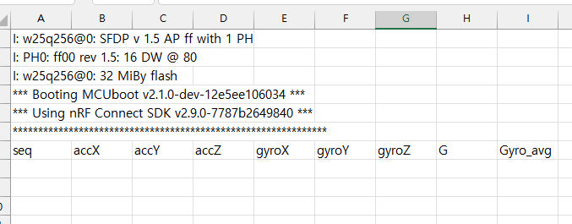

축 데이터 테스트
- 정상 작동 확인 완료 (기존 CL2-nRF-1.1.0 과 동일 축)
  - 기본 스탠딩
AX, AZ = 0, AY = - 1
  - 전방 숙임
AX, AY = 0, AZ = - 1
  - 좌측 숙임
AY, AZ = 0, AX = + 1
- 순서대로 기본 스탠딩, 전방 숙임, 좌측 숙임 데이터
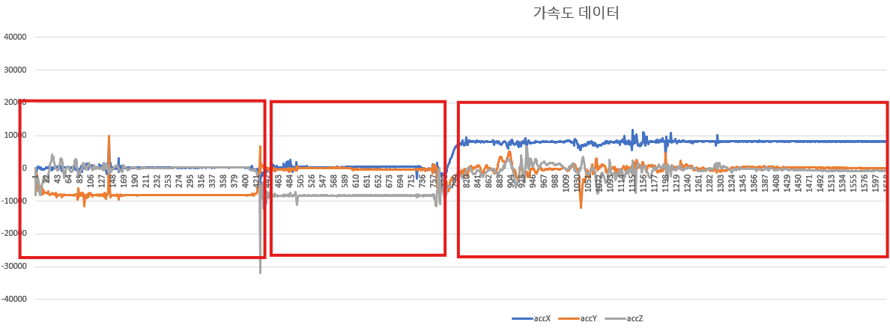

RTC 테스트
- Set RTC 설정 완료
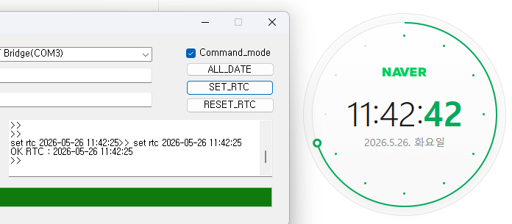

Dnt -0 로그 테스트
- 전체 로그 기록 출력
dnt -o
trigger, enabled.
>> dnt -o
0000 time[1] : 2000-01-01 00:00:00 0 B:1
0001 time[0] : 2000-01-01 00:00:00 0 B:1
0002 time[1] : 2000-01-01 00:00:00 51 B:2
0003 time[2] : 2025-08-27 16:51:42 51 T:2
0004 time[0] : 2025-08-27 16:51:38 51 B:2
0005 time[1] : 2025-10-29 08:54:04 43 B:3
0006 time[0] : 2025-10-29 08:54:04 43 B:3
0007 time[1] : 2025-10-29 08:55:18 44 B:4
0008 time[0] : 2025-10-29 08:55:18 44 B:4
0009 time[1] : 2025-11-03 13:09:18 46 B:5
0010 time[0] : 2025-11-03 13:09:18 46 B:5
0011 time[1] : 2025-11-03 13:17:04 46 B:6
0012 time[0] : 2025-11-03 13:17:04 46 B:6
0013 time[1] : 2025-11-03 13:18:10 44 B:7
0014 time[0] : 2025-11-03 13:18:10 44 B:7
0015 time[1] : 2025-11-04 15:21:17 43 B:8
0016 time[0] : 2025-11-04 15:21:17 43 B:8
0017 time[1] : 2025-11-04 15:22:04 45 B:9
0018 time[0] : 2025-11-04 15:22:04 45 B:9
0019 time[1] : 2025-11-04 15:26:04 43 B:10
0020 time[0] : 2025-11-04 15:26:04 43 B:10
0021 time[1] : 2025-11-05 10:20:09 44 B:11
0022 time[0] : 2025-11-05 10:20:09 44 B:11
0023 time[1] : 2026-04-14 16:53:41 40 B:12
0024 time[0] : 2026-04-14 16:53:42 40 B:12
0025 time[1] : 2000-01-01 00:00:00 40 B:13
0026 time[0] : 2000-01-01 00:00:00 40 B:13
0027 time[1] : 2000-01-01 00:00:20 42 B:14
0028 time[0] : 2026-04-14 16:16:33 42 B:14
0029 time[1] : 2000-01-01 00:00:00 41 B:15
0030 time[0] : 2026-04-14 16:17:34 41 B:15
0031 time[1] : 2000-01-01 00:00:00 0 B:16
0032 time[0] : 2000-01-01 00:00:00 0 B:16
0033 time[1] : 2000-01-01 00:00:13 0 B:17
0034 time[0] : 2000-01-01 00:00:13 0 B:17
0035 time[1] : 2000-01-01 00:00:32 0 B:18
0036 time[0] : 2000-01-01 00:00:32 0 B:18
0037 time[1] : 2000-01-01 00:00:46 72 B:19
0038 time[0] : 2000-01-01 00:00:46 72 B:19
0039 time[1] : 2000-01-01 00:00:49 71 B:20
0040 time[0] : 2000-01-01 00:00:49 71 B:20
0041 time[1] : 2000-01-01 00:05:39 0 B:21
0042 time[0] : 2000-01-01 00:05:39 0 B:21
0043 time[1] : 2000-01-01 00:06:22 0 B:22
0044 time[0] : 2000-01-01 00:06:22 0 B:22
0045 time[1] : 2000-01-01 00:06:36 72 B:23
0046 time[0] : 2026-04-14 16:37:00 72 B:23
0047 time[1] : 2000-01-01 00:00:00 72 B:24
0048 time[0] : 2026-04-14 16:39:05 72 B:24
0049 time[1] : 2026-04-14 16:39:23 72 B:25
0050 time[0] : 2026-04-14 16:39:24 72 B:25
0051 time[1] : 2026-04-14 16:40:56 0 B:26
0052 time[0] : 2026-04-14 16:40:57 0 B:26
0053 time[1] : 2026-04-14 16:41:10 0 B:27
0054 time[0] : 2026-04-14 16:41:11 0 B:27
0055 time[1] : 2026-04-14 16:41:19 72 B:28
0056 time[0] : 2026-04-14 16:41:20 72 B:28
0057 time[1] : 2000-01-01 00:00:00 73 B:29
0058 time[0] : 2026-04-14 16:42:00 73 B:29
0059 time[1] : 2000-01-01 00:00:00 38 B:30
0060 time[0] : 2000-01-01 00:00:00 38 B:30
0061 time[1] : 2000-01-01 00:01:23 40 B:31
0062 time[0] : 2000-01-01 00:01:23 40 B:31
0063 time[1] : 2000-01-01 00:00:00 39 B:32
0064 time[0] : 2026-04-23 10:37:17 39 B:32
0065 time[1] : 2026-04-23 10:37:27 40 B:33
0066 time[2] : 2026-04-23 10:37:32 40 T:3
0067 time[0] : 2026-04-23 10:37:28 40 B:33
0068 time[1] : 2000-01-01 00:00:00 0 B:34
0069 time[0] : 2000-01-01 00:00:00 0 B:34
0070 time[1] : 2000-01-01 00:00:10 0 B:35
0071 time[4] : 2000-01-01 00:00:10 0 F:0100
0072 time[0] : 2000-01-01 00:00:10 0 B:35
0073 time[1] : 2000-01-01 00:39:27 70 B:36
0074 time[4] : 2000-01-01 00:39:27 0 F:0500
0075 time[0] : 2026-04-23 11:38:41 70 B:36
0076 time[1] : 2026-04-23 11:38:46 71 B:37
0077 time[0] : 2026-04-23 11:38:47 71 B:37
0078 time[1] : 2026-04-23 11:38:54 71 B:38
0079 time[0] : 2026-04-23 11:38:55 71 B:38
0080 time[1] : 2026-04-23 11:42:41 71 B:39
0081 time[4] : 2026-04-23 11:42:41 0 F:0400
0082 time[0] : 2026-04-23 11:42:41 71 B:39
0083 time[1] : 2026-04-23 11:43:05 73 B:40
0084 time[4] : 2026-04-23 11:43:05 0 F:0400
0085 time[0] : 2026-04-23 11:43:05 73 B:40
0086 time[1] : 2026-04-23 11:44:18 73 B:41
0087 time[4] : 2026-04-23 11:44:18 0 F:0400
0088 time[0] : 2026-04-23 11:44:18 73 B:41
0089 time[1] : 2026-04-23 13:47:59 73 B:42
0090 time[0] : 2026-04-23 13:50:21 72 B:43
0091 time[1] : 2026-04-30 13:29:26 72 B:44
0092 time[4] : 2026-04-30 13:29:26 0 F:0400
0093 time[0] : 2026-04-30 13:29:26 72 B:44
0094 time[1] : 2026-04-30 13:33:20 73 B:45
0095 time[0] : 2026-04-30 13:33:51 72 B:45
0096 time[1] : 2026-04-30 13:33:54 73 B:46
0097 time[0] : 2026-04-30 13:33:55 73 B:46
0098 time[1] : 2026-04-30 13:34:15 72 B:47
0099 time[0] : 2026-04-30 13:34:16 72 B:47
0100 time[1] : 2026-04-30 13:35:10 71 B:48
0101 time[0] : 2026-04-30 13:35:11 71 B:48
0102 time[1] : 2026-04-30 13:35:38 72 B:49
0103 time[0] : 2026-04-30 13:35:39 72 B:49
0104 time[1] : 2026-04-30 13:36:03 71 B:50
0105 time[0] : 2026-04-30 13:36:04 71 B:50
0106 time[1] : 2026-04-30 13:36:35 72 B:51
0107 time[0] : 2026-04-30 13:36:36 72 B:51
0108 time[1] : 2026-04-30 13:40:40 0 B:52
0109 time[0] : 2026-04-30 13:40:40 0 B:52
0110 time[1] : 2026-04-30 13:40:53 72 B:53
0111 time[0] : 2026-04-30 13:40:54 72 B:53
0112 time[1] : 2026-05-06 09:21:06 70 B:54
0113 time[0] : 2026-05-06 09:21:36 70 B:54
0114 time[1] : 2026-05-06 09:22:04 70 B:55
0115 time[0] : 2026-05-06 09:22:35 70 B:55
0116 time[1] : 2026-05-06 09:23:52 70 B:56
0117 time[0] : 2026-05-06 09:23:53 70 B:56
0118 time[1] : 2026-05-06 09:24:35 70 B:57
0119 time[0] : 2026-05-06 09:25:06 70 B:57
0120 time[1] : 2026-05-06 09:25:36 70 B:58
0121 time[0] : 2026-05-06 09:26:07 70 B:58
0122 time[1] : 2026-05-06 09:28:30 70 B:59
0123 time[0] : 2026-05-06 09:28:30 70 B:59
0124 time[1] : 2026-05-06 09:29:15 70 B:60
0125 time[0] : 2026-05-06 09:29:16 70 B:60
0126 time[1] : 2026-05-06 09:29:29 71 B:61
0127 time[0] : 2026-05-06 09:29:30 71 B:61
0128 time[1] : 2026-05-06 09:31:13 70 B:62
0129 time[0] : 2026-05-06 09:31:44 70 B:62
0130 time[1] : 2026-05-06 09:35:04 71 B:63
0131 time[0] : 2026-05-06 09:35:04 71 B:63
0132 time[1] : 2026-05-06 09:35:57 71 B:64
0133 time[0] : 2026-05-06 09:35:58 71 B:64
0134 time[1] : 2026-05-06 09:36:18 70 B:65
0135 time[0] : 2026-05-06 09:36:19 70 B:65
0136 time[1] : 2026-05-06 09:36:50 70 B:66
0137 time[0] : 2026-05-06 09:36:51 70 B:66
0138 time[1] : 2026-05-06 09:38:36 70 B:67
0139 time[0] : 2026-05-06 09:38:37 70 B:67
0140 time[1] : 2026-05-06 09:46:11 72 B:68
0141 time[0] : 2026-05-06 09:46:11 72 B:68
0142 time[1] : 2026-05-06 09:46:23 71 B:69
0143 time[0] : 2026-05-06 09:46:54 71 B:69
0144 time[1] : 2026-05-06 09:51:34 72 B:70
0145 time[0] : 2026-05-06 09:51:35 72 B:70
0146 time[1] : 2026-05-06 09:51:53 71 B:71
0147 time[0] : 2026-05-06 09:51:54 71 B:71
0148 time[1] : 2026-05-06 09:52:19 71 B:72
0149 time[0] : 2026-05-06 09:53:20 72 B:72
0150 time[1] : 2026-05-06 09:53:24 71 B:73
0151 time[0] : 2026-05-06 09:53:25 71 B:73
0152 time[1] : 2026-05-06 09:53:50 70 B:74
0153 time[0] : 2026-05-06 09:53:51 70 B:74
0154 time[1] : 2026-05-06 09:59:06 69 B:75
0155 time[0] : 2026-05-06 09:59:07 69 B:75
0156 time[1] : 2026-05-06 10:01:47 72 B:76
0157 time[0] : 2026-05-06 10:01:48 72 B:76
0158 time[1] : 2026-05-06 10:02:15 71 B:77
0159 time[0] : 2026-05-06 10:02:15 71 B:77
0160 time[1] : 2026-05-06 10:02:59 71 B:78
0161 time[0] : 2026-05-06 10:04:22 71 B:79
0162 time[1] : 2026-05-06 10:06:49 72 B:80
0163 time[0] : 2026-05-06 10:06:50 72 B:80
0164 time[1] : 2026-05-06 10:06:59 71 B:81
0165 time[0] : 2026-05-06 10:21:09 70 B:91
0166 time[1] : 2026-05-06 17:48:48 0 B:92
0167 time[0] : 2026-05-06 17:49:49 0 B:92
0168 time[1] : 2026-05-06 17:50:00 0 B:93
0169 time[0] : 2026-05-06 17:50:31 0 B:93
0170 time[1] : 2026-05-11 11:20:34 70 B:94
0171 time[2] : 2026-05-11 11:20:37 70 T:3
0172 time[0] : 2026-05-11 11:20:39 70 B:94
0173 time[1] : 2026-05-11 11:20:40 71 B:95
0174 time[0] : 2026-05-11 11:20:41 71 B:95
0175 time[1] : 2026-05-11 11:54:06 70 B:96
0176 time[0] : 2026-05-11 11:54:07 70 B:96
0177 time[1] : 2026-05-11 11:54:30 71 B:97
0178 time[0] : 2026-05-11 11:53:30 70 B:98
0179 time[1] : 2026-05-11 13:11:19 69 B:99
0180 time[0] : 2026-05-11 13:11:20 69 B:99
0181 time[1] : 2026-05-11 13:11:46 70 B:100
0182 time[0] : 2026-05-11 13:18:14 0 B:104
0183 time[1] : 2026-05-11 13:34:34 70 B:105
0184 time[0] : 2026-05-11 13:35:57 70 B:106
0185 time[1] : 2026-05-11 13:37:11 69 B:107
0186 time[0] : 2026-05-11 13:37:42 69 B:107
0187 time[1] : 2026-05-11 13:38:34 70 B:108
0188 time[0] : 2026-05-11 13:42:40 0 B:111
0189 time[1] : 2026-05-22 13:23:57 66 B:112
0190 time[0] : 2026-05-22 13:24:27 66 B:112
0191 time[1] : 2026-05-22 13:24:31 67 B:113
0192 time[0] : 2026-05-22 13:26:54 66 B:114
0193 time[1] : 2026-05-22 13:43:23 68 B:115
0194 time[0] : 2026-05-22 13:43:23 68 B:115
0195 time[1] : 2026-05-22 13:43:44 66 B:116
0196 time[0] : 2026-05-22 13:43:45 66 B:116
0197 time[1] : 2026-05-22 13:44:06 69 B:117
0198 time[0] : 2026-05-22 13:44:07 69 B:117
0199 time[1] : 2026-05-22 13:44:27 67 B:118
0200 time[4] : 2026-05-22 13:44:23 0 F:0076
0201 time[0] : 2026-05-22 13:44:28 67 B:118
0202 time[1] : 2026-05-22 13:45:02 0 B:119
0203 time[0] : 2026-05-22 13:45:03 0 B:119
0204 time[1] : 2026-05-22 13:47:45 69 B:120
0205 time[4] : 2026-05-22 13:47:45 69 F:0078
0206 time[0] : 2026-05-22 13:47:45 69 B:120
0207 time[1] : 2026-05-22 13:48:10 66 B:121
0208 time[0] : 2026-05-22 13:48:11 66 B:121
0209 time[1] : 2026-05-22 13:50:51 0 B:122
0210 time[3] : 2026-05-26 11:06:46 -1 B:0
0211 time[0] : 2026-05-22 13:51:02 -67 B:122
0212 time[1] : 2026-05-26 11:06:56 67 B:123
0213 time[0] : 2026-05-26 11:07:22 -67 B:123
0214 time[1] : 2026-05-26 11:07:21 67 B:124
0215 time[0] : 2026-05-26 11:08:02 -67 B:124
0216 time[1] : 2026-05-26 11:08:02 67 B:125
0217 time[0] : 2026-05-26 11:08:59 -67 B:125
0218 time[1] : 2026-05-26 11:08:57 67 B:126
0219 time[0] : 2026-05-26 11:10:14 -67 B:126
0220 time[1] : 2026-05-26 11:10:15 67 B:127
0221 time[0] : 2026-05-26 11:11:02 -67 B:127
0222 time[1] : 2026-05-26 11:10:59 67 B:128
0223 time[0] : 2026-05-26 11:11:15 -66 B:128
0224 time[1] : 2026-05-26 11:11:16 66 B:129
0225 time[2] : 1970-01-01 14:15:49 66 T:5
0226 time[3] : 2026-05-26 11:11:46 -1 B:0
0227 time[0] : 2026-05-26 11:11:47 -65 B:129
0228 time[1] : 2026-05-26 11:11:49 65 B:130
0229 time[0] : 2026-05-26 11:13:01 -68 B:130
0230 time[1] : 2026-05-26 11:13:03 68 B:131
0231 time[2] : 2106-02-02 21:17:30 68 T:5
0232 time[0] : 2026-05-26 11:13:34 -67 B:131
0233 time[1] : 2026-05-26 11:13:46 67 B:132
0234 time[0] : 2026-05-26 11:17:24 -66 B:134
0235 time[1] : 2026-05-26 11:17:21 66 B:135
0236 time[0] : 2026-05-26 11:18:23 -69 B:135
0237 time[1] : 2026-05-26 11:18:22 69 B:136
0238 time[0] : 2026-05-26 11:32:59 -68 B:146
0239 time[1] : 2026-05-26 11:32:59 68 B:147
0240 time[0] : 2026-05-26 11:37:21 -64 B:148
0241 time[1] : 2026-05-26 11:37:22 64 B:149
0242 time[0] : 2106-02-07 03:41:45 -67 B:151
0243 time[1] : 2026-05-26 11:40:44 67 B:152
0244 time[0] : 2106-02-07 00:43:48 -65 B:160
0245 time[1] : 2026-05-26 11:50:10 65 B:161
>>
>> ?X
------------------------------------------------------------------------------
?X : not defined.
##############################################################################
>> ?X
------------------------------------------------------------------------------
?X : not defined.
##############################################################################

BLE 연결 테스트
- 연결 시 펌웨어 정보가 출력이 안되는 이슈
시리얼 포트 상에서는 BLE connected 메시지가 나타나지만 파스칼리아에서는 show info 메시지만 나타남 (명령어 응답 없음)
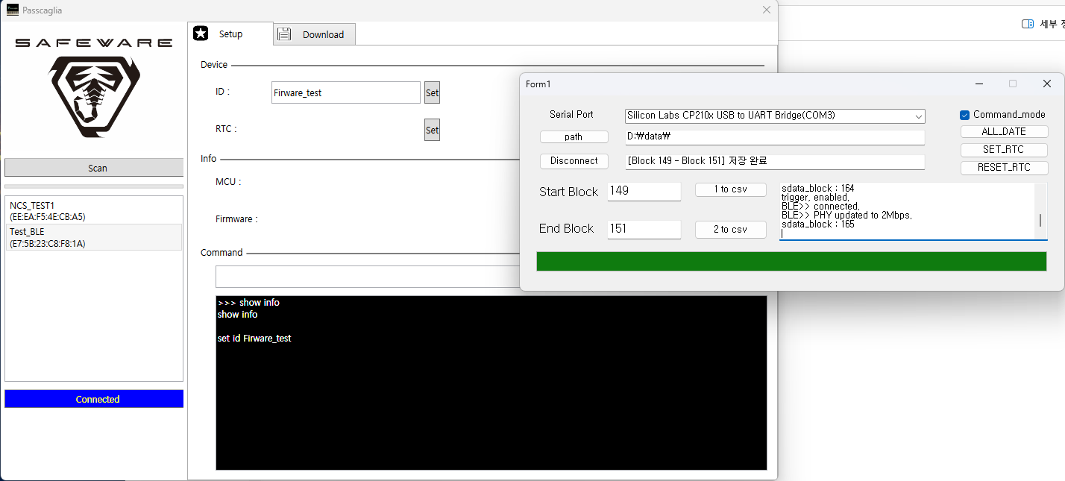

- Show info (처음 연결 시) 명령어가 간혹 작동하는 경우도 존재
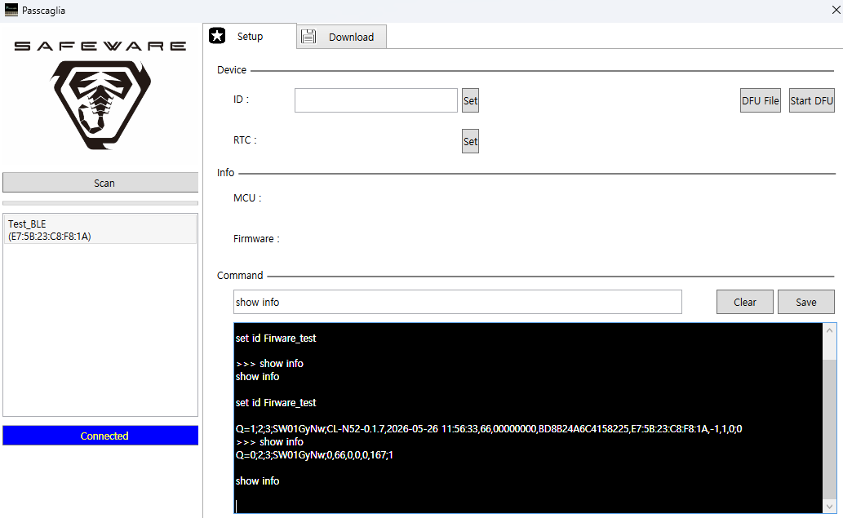

- Set id 명령어도 반응 없음
여러 번 시도해도 BLE 연결 시 이름이 바뀌지 않음
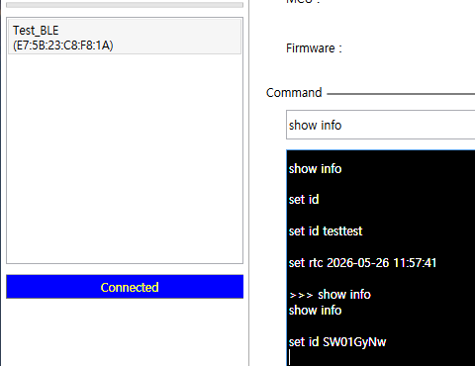

- Run Log 실행 시 반응 없음
